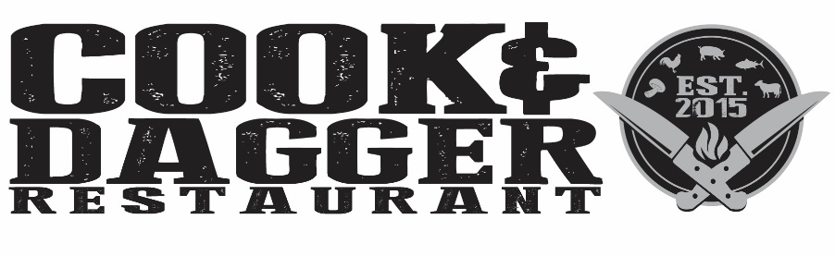

Starters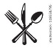

Croquettes $7

Manchego Cheese, Serrano Ham, Chipotle Aioli

House Cured Assorted Olives $6

Crispy Brussels Sprouts $7

Goat Cheese, Lemon Caper Aioli

Wings $12

Buffalo, BBQ, or Wing Du Jour

Calamari $10

Fresno Peppers, Pickled Onions, Arugula, Harissa Butter

Mussels Verde $12

Garlic, Shallots, Herbs, Butter

Charred Octopus $11

Crispy Chick Peas, Arugula, Pickled Onions, Chorizo Vinaigrette

Pork Belly Quesadilla $11

Queso Blanco, Charred Pineapple, Poblano, Leeks, Confit Radish

\*Consuming raw or undercooked meats, poultry, shellfish, or eggs may increase your risk of foodborne illness

Please inform your server of any food allergies

Soups & Salads

New England Clam Chowda\* $7

Cream, Potato, Dill, and Bacon

Gumbo $7

Andouille Sausage, Chicken, Holy Trinity

House Salad $6

Mixed Greens, Tomato, Cucumber, Onion, Radish, Carrot, Sherry Vinaigrette

Beet Salad $9

Beets 3 Ways, Mustard Vinaigrette, Beet Green Chimichurri, Goat Cheese Croutons

Caesar Salad $10

Grilled Hearts of Romaine, House Made Creamy Caesar Dressing, Parmesan, Crostini Add: Shrimp $8, Chicken $5

Chef Salad $12

Mixed Greens, Ham, Chicken, Hard Boiled Egg, Fingerling Potatoes, Tomato, Onion, Buttermilk Dill

Sammies & Fries

Cheeseburger\* $13

American & Cheddar Cheeses, Lettuce, Tomato, Add: Bacon, Egg, Caramelized Onions, Mushrooms, or Truffle Aioli for $1 each

Grilled Cheese & Tomato Bisque $13

Sharp Cheddar, Bacon Jam, Sliced Apple Served with a Bowl of Tomato Bisque

Lamb Burger $15

Harissa Yogurt, Arugula, House Pita

Roasted Pork Loin Sandwich $12

Shaved Pork Loin, Honey Mustard, Baby Swiss, Sweet Onion Relish, Grilled Baguette

Plates

Chicken & Dumplings $18

Pan Seared Statler, Baby Carrots, Celery, Cream, Dumplings

Grilled Sirloin Steak\* $26

Crispy Fingerling, Brussels Sprouts, Salsa Verde

Salmon $21

Lentils, Roasted Cauliflower, Charred Herb Salsa

Ricotta Gnocchi Bolognese $21

Low Country Carbonara\* $18

Serrano Ham, Pork Belly, Manchego, Poached Egg, Wild Mushrooms tossed with Linguine

Fish Tacos Mkt

Corn Meal Crusted Fresh Fish, Pico de Gallo, Buttermilk Dill Slaw, Rice & Black Beans

Grill for 2  $48

Grilled Sirloin Steak, Statler, Pork Belly, Sausage, Fries

On the Side

Hand Cut Fries $4

Brussels Sprouts $5

Baby Carrots $5

Fingerling Potatoes $5

Side Salad $4