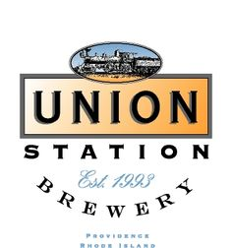

BEER

LIGHTHOUSE LAGER
CLEAN, CRISP PILSNER
(ABV 4.8%) (IBU 20) (OG 11 °P)

BALTIC PORTER
LAGER WITH NOTES OF CHOCOLATE, BISCUIT, DRIED FRUIT AND COFFEE
(ABV 6.3%) (IBU 32) (OG 14.7 °P)

THE NIT WIT
BELGIAN WITBIER WITH ORANGE PEEL, CORIANDER AND CHAMOMILE FLOWERS
(ABV 5.3%) (IBU 17) (OG 13.1 °P)

SAISON OF THE WITCH
SAISON BREWED EXCLUSIVELY WITH AMARILLO HOPS, EARTHY NOTES OF BLACK PEPPER AND PEAR
(ABV 6.8%) (IBU 24) (OG 14.3 °P)

HARVEST AMBER ALE
AMBER ALE CONDITIONED ON HARVEST SPICES
(ABV 7%) (IBU 18) (OG 16.5°P)

GUEST TAPS:
SMUG BREWING’S LAST LOOK IPA
A SMOOTH, TROPICAL AND FRUITY IPA WITH AN ABV OF 7.8%

