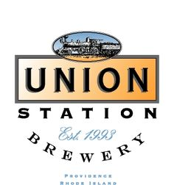

WEEKLY SPECIALS

STEAK AND CHEESE EGG ROLLS $10.99
SAUTEED STEAK, PEPPERS, ONIONS & MOZZARELLA CHEESE ROLLED IN A CRISPY WRAPPER SERVED WITH SPICY AIOLI AND FRIEND ONION TANGLES

ALMOND CRUSTED GOAT CHEESE AND BERRY SALAD $12.99
ALMOND & GRAHAM COATED GOAT CHEESE SERVED OVER MIXED GREENS WITH SEASONAL BERRIES, CANDIED PECANS TOPPED WITH BERRY VINAIGRETTE

IPA BRAISED SHORT RIB MELT $12.99
SLICED BEER BRAISED SHORT RIB, CHEDDAR CHEESE, GARLIC AIOLI, TOMATO, GREEN LEAF ON TOASTED FRENCH BREAD

BACON BLUE BURGER $12.99
GRILLED HAND CRAFTED BURGER TOPPED WITH BOURBON BACON JAM, CRUMBLED BLUE CHEESE, MUSHROOMS TOPPED WITH CHIPOTLE AIOLI ON BRIOCHE

CHICKEN PICCATA $16.99
PAN-SEARED CHICKEN TENDERLOINS OVER FETTUCCINE IN A LEMON CREAM SAUCE WITH CAPERS, DICED TOMATO, AND SPINACH

