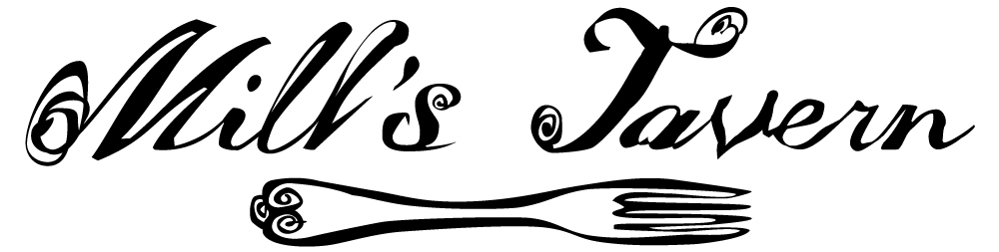

**BAR BITES MENU**

**Oyster on the Half Shell**

One Half Dozen 10.50

One Dozen 21.00

Limit One Dozen per Guest

**Chilled Poached U16 Shrimp**

By the Each 2.50

**Ceviche**

Chef’s Choice of Fresh Seafood in a Citrus Marinade

15

**Calamari**

With Fresh

Pepper Rings and Marinara

10.00

**Mill’s Bar Board**

A Selection of Cheeses and Meats Hand Chosen by Chef Bolus

15

**Lamb Lollipops**

Served with Tzatziki and Mint Demi-Glace

17

**Bluefish Pate**

12

Bar Bites Menu is Available at the bar exclusively





**BAR BITES MENU**

**Oyster on the Half Shell**

One Half Dozen 10.50

One Dozen 21.00

Limit One Dozen per Guest

**Chilled Poached U16 Shrimp**

By the Each 2.50

**Ceviche**

Chef’s Choice of Fresh Seafood in a Citrus Marinade

15

**Calamari**

With Fresh

Pepper Rings and Marinara

10.00

**Mill’s Bar Board**

A Selection of Cheeses and Meats Hand Chosen by Chef Bolus

15

**Lamb Lollipops**

Served with Tzatziki and Mint Demi-Glace

17

**Bluefish Pate**

12

Bar Bites Menu is Available at the bar exclusively





**BAR BITES MENU**

**Oyster on the Half Shell**

One Half Dozen 10.50

One Dozen 21.00

Limit One Dozen per Guest

**Chilled Poached U16 Shrimp**

By the Each 2.50

**Ceviche**

Chef’s Choice of Fresh Seafood in a Citrus Marinade

15

**Calamari**

With Fresh

Pepper Rings and Marinara

10.00

**Mill’s Bar Board**

A Selection of Cheeses and Meats Hand Chosen by Chef Bolus

15

**Lamb Lollipops**

Served with Tzatziki and Mint Demi-Glace

17

**Bluefish Pate**

12

Bar Bites Menu is Available at the bar exclusively





**BAR BITES MENU**

**Oyster on the Half Shell**

One Half Dozen 10.50

One Dozen 21.00

Limit One Dozen per Guest

**Chilled Poached U16 Shrimp**

By the Each 2.50

**Ceviche**

Chef’s Choice of Fresh Seafood in a Citrus Marinade

15

**Calamari**

With Fresh

Pepper Rings and Marinara

10.00

**Mill’s Bar Board**

A Selection of Cheeses and Meats Hand Chosen by Chef Bolus

15

**Lamb Lollipops**

Served with Tzatziki and Mint Demi-Glace

17

**Bluefish Pate**

12

Bar Bites Menu is Available at the bar exclusively



