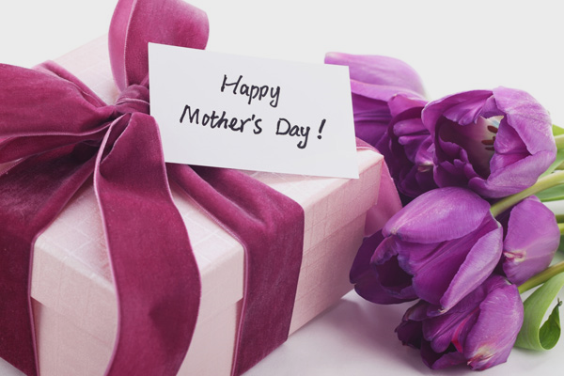

Mother’s Day
Brunch Buffet
At NYLO

Sunday, May 14th

Serving Times
10am | 12:30pm | 3pm

All seating’s are allotted
for two hours

$40 Adults
$20 Children under 12

Book your reservation by calling
401.734.4460

ALL RESERVATIONS REQUIRE A CREDIT CARD
AT THE TIME OF BOOKING

400 Knight Street
Warwick | RI | 02886 401.734.4460
www.nylohotels.com/warwick

BREAKFAST STATION
Eggs Benedict | Scrambled eggs
Crepes Stuffed with Mascarpone & Ricotta Cheese
Served with Raspberry & Blueberry Maple Syrup
Breakfast Potatoes
Country Sausage | Smoked Bacon
Breakfast Pastries | Breads
Seasonal Sliced Fruit

LUNCH STATION
Crab Stuffed Sole | Chicken Piccata
Crispy Brussel Sprouts | Spring Veggie Melody
Calzones | Frittatas

SALAD STATION
Mixed Green Salad | Cesar Salad | Caprese Salad

CHEF ATTENDED PASTA STATION
Tortellini
Assorted Vegetables | Meats
Pomodoro Sauce | Pink Sauce

CHEF’S CARVING STATION
Prime Rib
Pork Tenderloin
Accompaniments | Assorted Rolls

DESSERTS
Cup Cakes | Cake Bites | Cannoli | Mini Pastries

